صفحة 1
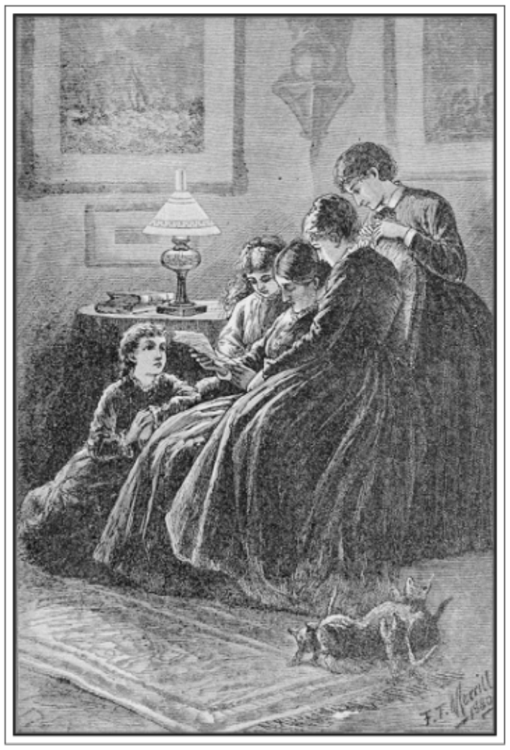
"They all drew to the fire, mother in the big chair, with Beth at her feet"
(See page 9) FRONTISPIECE
LITTLE WOMEN
OR
Meg, Jo, Beth, and Amy
BY
LOUISA M. ALCOTT

